August 3, 2023 - Etna California Precipitation Event
Scott River Watershed Council

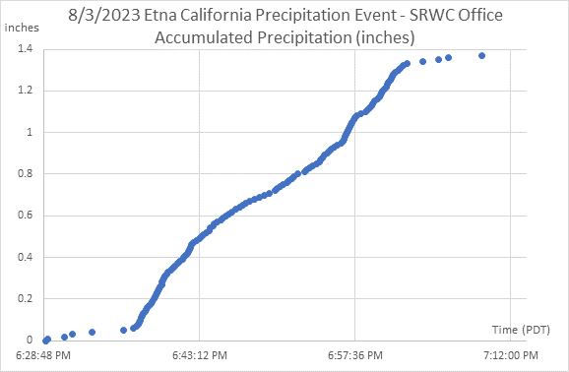
Figure 1 – Accumulated precipitation (inches) – August 3, 2023

A severe thunderstorm occurred in Etna California on August 3, 2023. Using an Onset Computer Corporation tipping rain bucket, 1.39 inches of precipitation was measured at the Scott River Watershed Council office located at 514 N. Hwy. 3, in Etna from 6:29 PM to 7:15 PM (PDT) (Figure 1). The majority of the precipitation (1.28 inches) fell in a 26-minute period from to 6:36 PM to 7:02 PM (PDT) at a rate of 2.9 inches per hour.

